Part (a)

|  |  |  |
| --- | --- | --- |
|  | Table | Description & describe possible Use of table |
| 1 | film_category | Contains the Category of films in dvd database, can be used to search the film which the user wants by category |
| 2 | rental | Contains rental information about dvd rentals such as date of issue, date of return. It can be used for renting dvd to user |
| 3 | store | Contains information about store such as address, staff, manager. It can be used as a store locator for customers |
| 4 | film_actor | Contains information about film and actor who has acted in that film. Can be used to identify latest and best films of a particular actor. |
| 5 | inventory | Contains information about store,and films present in that store. Can be used to check remaining stock of films at any store. |

Part (b) Paste Screenshot here

1. [SELECT](http://localhost/phpmyadmin/url.php?url=https://dev.mysql.com/doc/refman/5.5/en/select.html) * FROM actor WHERE last_name [LIKE](http://localhost/phpmyadmin/url.php?url=https://dev.mysql.com/doc/refman/5.5/en/string-comparison-functions.html#operator_like) "Davis%"

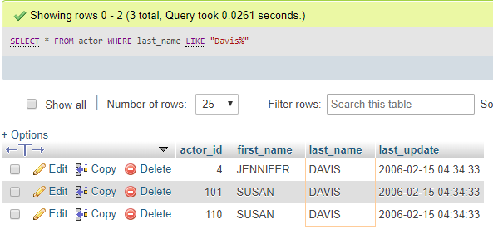

1. [SELECT](http://localhost/phpmyadmin/url.php?url=https://dev.mysql.com/doc/refman/5.5/en/select.html) * FROM actor WHERE last_name [LIKE](http://localhost/phpmyadmin/url.php?url=https://dev.mysql.com/doc/refman/5.5/en/string-comparison-functions.html#operator_like) "D%s"

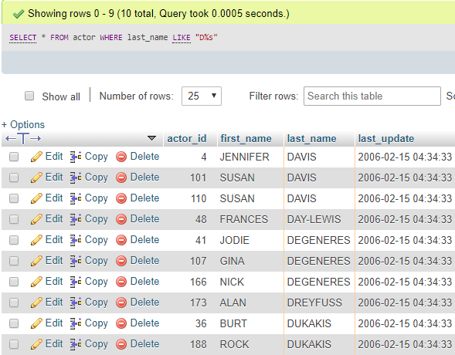

1. [SELECT](http://localhost/phpmyadmin/url.php?url=https://dev.mysql.com/doc/refman/5.5/en/select.html) * FROM actor WHERE last_name [LIKE](http://localhost/phpmyadmin/url.php?url=https://dev.mysql.com/doc/refman/5.5/en/string-comparison-functions.html#operator_like) "____"

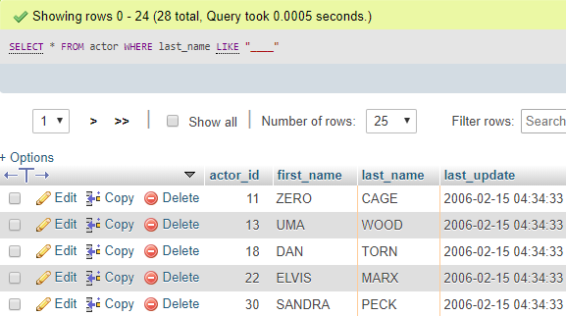

1. SELECT * FROM actor WHERE last_name LIKE "D___"

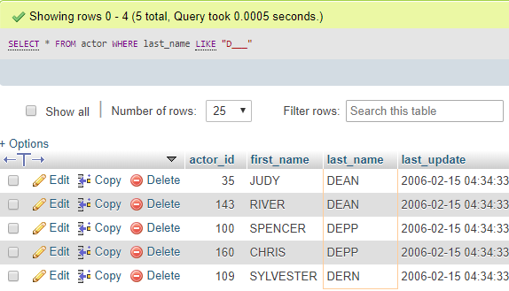

1. SELECT * FROM actor WHERE last_name LIKE "D__N"

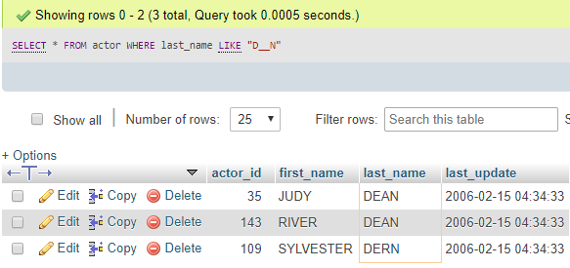

1. SELECT * FROM actor WHERE first_name LIKE "D%" AND last_name LIKE "%S"

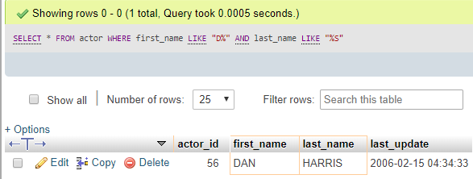

1. SELECT COUNT(DISTINCT first_name) FROM actor

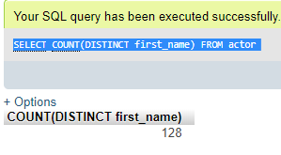

1. SELECT COUNT(first_name), first_name from actor GROUP by first_name HAVING COUNT(first_name)>1

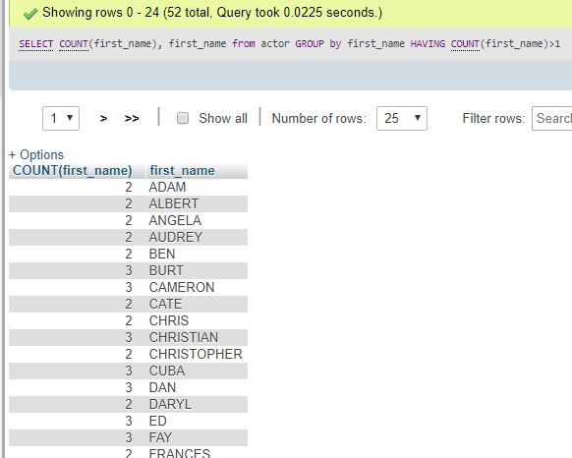

1. SELECT a.film_id,a.title,t.store_id from film_text a,store t where a.title="ANONYMOUS HUMAN" and t.store_id=2

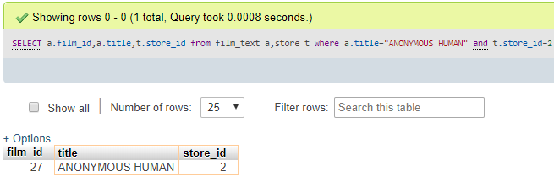

1. SELECT film_actor.actor_id,actor.first_name,actor.last_name,COUNT((film_id)) as filmidd FROM film_actor INNER JOIN actor ON film_actor.actor_id=actor.actor_id GROUP BY actor_id ORDER BY COUNT((film_id)) DESC

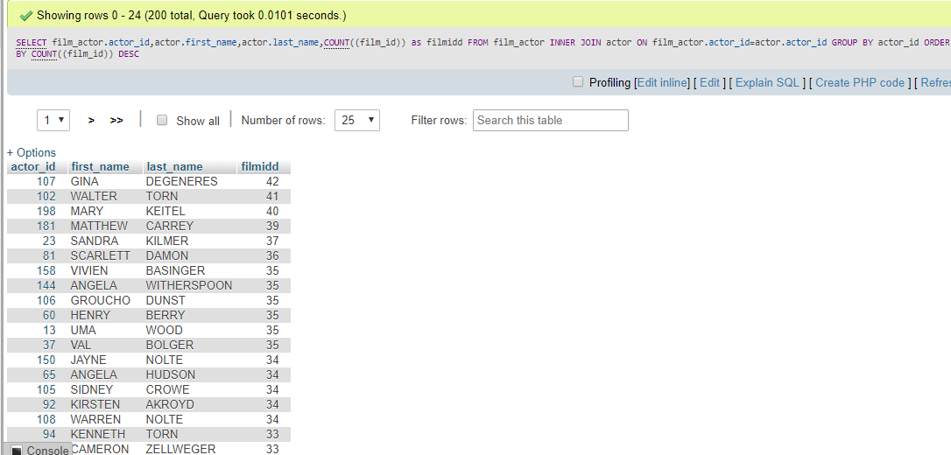

11. INSERT INTO `rental`(`rental_date`, `inventory_id`, `customer_id`, `staff_id`) VALUES ('2019-07-10 13:45:06','136','6','2')

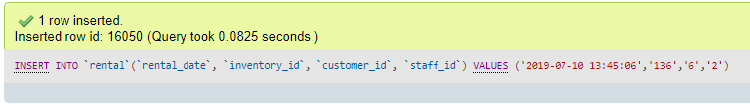

12. SELECT category_id,AVG(length) FROM `film_category`, film WHERE film_category.film_id = film.film_id GROUP BY category_id

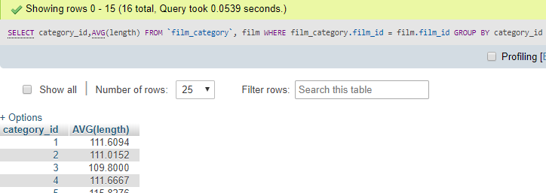

13. SELECT * FROM film NATURAL JOIN inventory



Here natural join does not give any output as compared to other types of joins, so it cannot be used in all cases and that is drawback of natural join.

14. SELECT film_id,title,length FROM film WHERE length > any (SELECT AVG(film.length) FROM film)

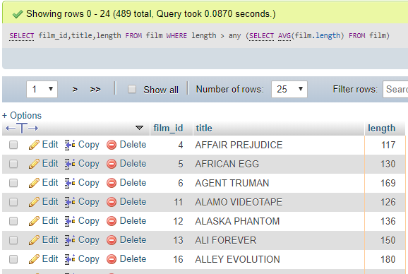

15. set @v1 = (SELECT rental_date FROM rental WHERE rental_id = 16050)

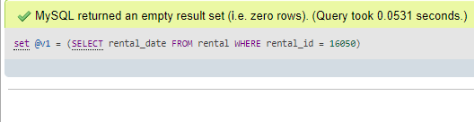

set @d1 = (SELECT date_add(@v1, INTERVAL 7 DAY))

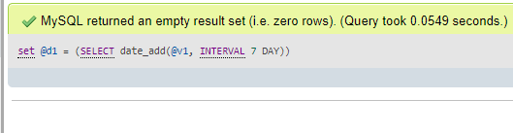

UPDATE rental SET return_date = @d1 WHERE rental_id = 16050

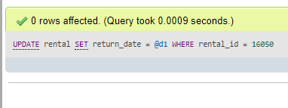

16. SELECT concat(ci.city,",", co.country) store, concat(first_name," ",last_name) AS manager, SUM(amount) total_sales FROM city ci,country co, staff s, payment p, address a WHERE (s.address_id = a.address_id) AND (a.city_id = ci.city_id) AND (ci.country_id = co.country_id) AND (s.staff_id = p.staff_id) GROUP BY s.staff_id ORDER BY manager

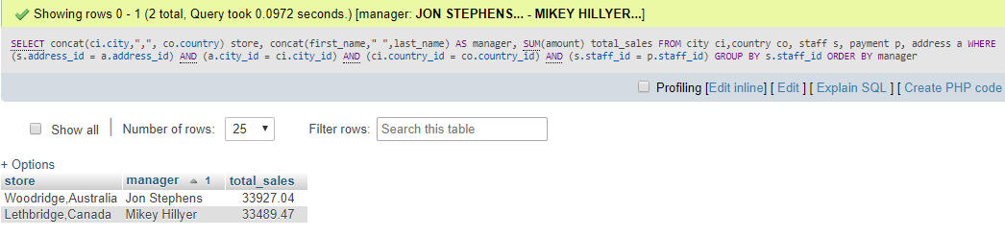

17. SELECT name category, SUM(amount) Total_Sales FROM category c, film_category fc, inventory i, rental r, payment p, film fi WHERE (c.category_id = fc.category_id) AND (fc.film_id = fi.film_id) AND (fi.film_id = i.film_id) AND (i.inventory_id = r.inventory_id) AND (r.rental_id = p.rental_id) GROUP BY category

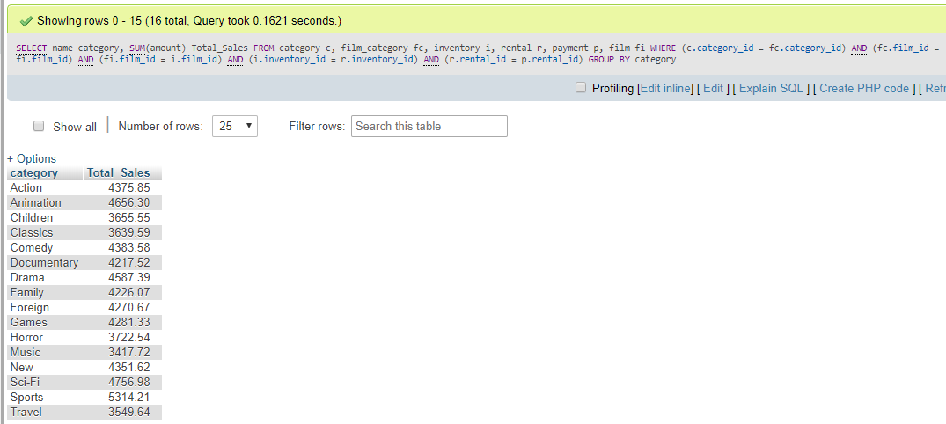

18. SELECT COUNT(*),staff_id FROM rental GROUP BY staff_id

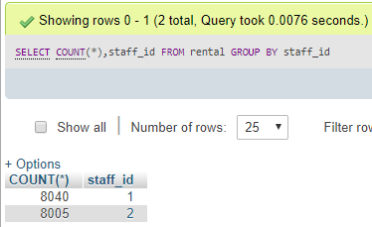

19. SELECT name FROM `category` ORDER BY name desc

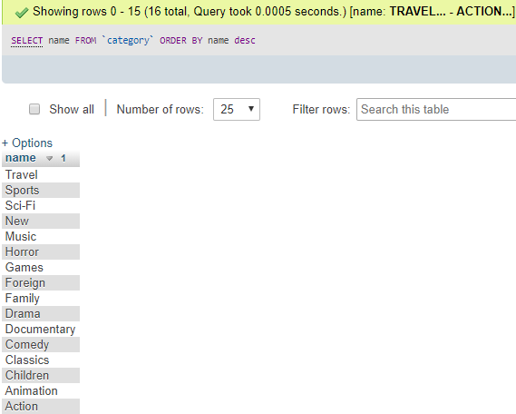

20. select s.staff_id id,concat(s.first_name,' ',s.last_name)as name,a.address address, a.postal_code zipcode,a.phone phone,b.city city,c.country country,s.staff_id sid FROM address a,city b,country c, staff s WHERE a.city_id=b.city_id and b.country_id=c.country_id and a.address_id=s.address_id

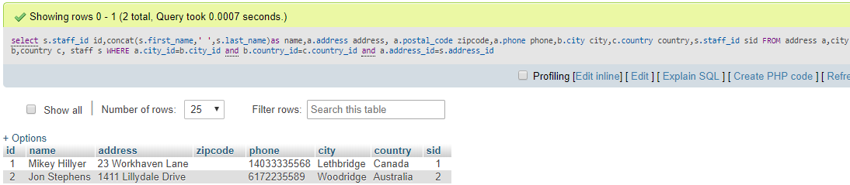

21. CREATE VIEW dvd_staff_info AS SELECT first_name,last_name,email,username FROM staff

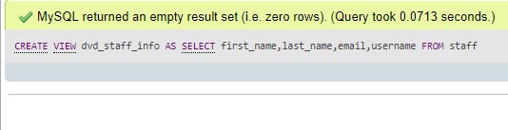

22. UPDATE `dvd_staff_info` SET `first_name`='Mikey' WHERE last_name = 'Hillyer'

